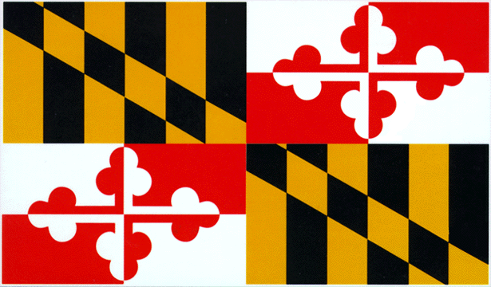State Council on Child Abuse and Neglect (SCCAN)
Meeting Agenda
November 6, 2025, 1:00-3:00 PM
2108 N Charles St, Baltimore, MD 21218
Join Zoom meeting:
https://maryland-gov-dhs.zoomgov.com/j/1609906593

AGENDA ITEM | LEAD FACILITATOR | TIME
- Zoom Entry & CHAT Introductions  - Welcome & Outline today’s Meeting Goals:  - Presentation and Discussion: Domestic Violence and Child Maltreatment  - Workgroup Updates  - Membership Update  - Legislative Update  - Partner Updates  - Next Steps and Adjourn | Ted Gallo | 10 minutes
- Presentation and Discussion: DV and Child Maltreatment | Paul Griffin | 45 minutes
- Workgroup Updates:  - Criminal Justice Act Committee (CJAC)  - Medical Workgroup  - Achieving Racial Equity  - Maryland Essentials for Childhood  - Pediatric Overstays Workgroup |  | 15 minutes
- Membership Update | Ted Gallo | 5 minutes
- Legislative Update | Ted Gallo | 30 Minutes
- Partner Updates | All | 10 minutes
- Next Steps & Adjourn | Ted Gallo | 5 minutes

